CSA5103-Cryptography And Network Security
Experiment 3
Aim:
To write a Python program to implement the Playfair Cipher using a 5 × 5 matrix generated from a keyword to encrypt plaintext two letters at a time.
Algorithm:
- Start the program.
- Read the keyword and plaintext from the user.
- Generate a 5 × 5 Playfair matrix using the keyword.
- Replace J with I.
- Divide the plaintext into pairs of letters.
- Insert X between repeated letters and at the end if required.
- Encrypt each pair using the Playfair rules:
  - Same row → Replace with the letter to the right.
  - Same column → Replace with the letter below.
  - Different row and column → Replace using the rectangle rule.
- Display the encrypted message.
- Stop the program.

Code:
# Playfair Cipher Encryption
def generate_matrix(key):
key = key.upper().replace("J", "I")
matrix = []
used = set()
for ch in key:
if ch.isalpha() and ch not in used:
matrix.append(ch)
used.add(ch)
for ch in "ABCDEFGHIKLMNOPQRSTUVWXYZ": # J is omitted
if ch not in used:
matrix.append(ch)
used.add(ch)
return [matrix[i:i+5] for i in range(0, 25, 5)]
def find_position(matrix, ch):
if ch == 'J':
ch = 'I'
for i in range(5):
for j in range(5):
if matrix[i][j] == ch:
return i, j
def prepare_text(text):
text = text.upper().replace("J", "I")
text = "".join(ch for ch in text if ch.isalpha())
result = ""
i = 0
while i < len(text):
a = text[i]
if i + 1 < len(text):
b = text[i + 1]
if a == b:
result += a + "X"
i += 1
else:
result += a + b
i += 2
else:
result += a + "X"
i += 1
return result
def encrypt(matrix, text):
cipher = ""
for i in range(0, len(text), 2):
a = text[i]
b = text[i + 1]
r1, c1 = find_position(matrix, a)
r2, c2 = find_position(matrix, b)
# Same row
if r1 == r2:
cipher += matrix[r1][(c1 + 1) % 5]
cipher += matrix[r2][(c2 + 1) % 5]
# Same column
elif c1 == c2:
cipher += matrix[(r1 + 1) % 5][c1]
cipher += matrix[(r2 + 1) % 5][c2]
# Rectangle rule
else:
cipher += matrix[r1][c2]
cipher += matrix[r2][c1]
return cipher
# Main Program
key = input("Enter the keyword: ")
plaintext = input("Enter the plaintext: ")
matrix = generate_matrix(key)
print("\nPlayfair Matrix:")
for row in matrix:
print(" ".join(row))
prepared = prepare_text(plaintext)
print("\nPrepared Text:", prepared)
ciphertext = encrypt(matrix, prepared)
print("Encrypted Text:", ciphertext)
Output:
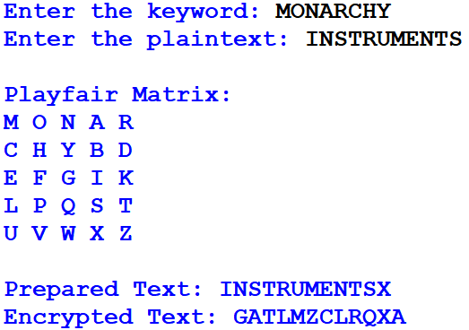
Result:
Thus, the Python program for the Playfair Cipher was implemented successfully, and the plaintext was encrypted correctly using the generated 5 × 5 matrix.

